Building and Deploying a Curved Screen

Introduction

This document describes the steps I used to design, purchase and deploy a curved screen for the Hornet. The screen is also able to be used for helicopter flights.

Whilst the fundamental steps for calibrating the screen is common for DCS and MSFS I found that I needed to use a stretched (aka Eyefinity) view for DCS but separate Windows for MSFS 2020. The meant that separate full alignment was needed for the different screen setups. Fortunately the spot markers had not been removed from an earlier run so a rough alignment took less than an hour. This does mean however that when swapping between DCS and MSFS that the Eyefinity settings must be changed and separate Fly Elise Configuration files need to be used (as opposed to just using different Config Sets). Further testing could be done to see if the DCS views can use separate windows instead of the Eyefinity configuration.

Table of Contents
Introduction 1
Design the Screen 1
Purchasing the Screen 2
Configuring the PC 4
Calibrating the Screen 5
Getting started with Calibration Pro 5
Immersaview Pro 16
Immersive Display Pro Operations 18
Configuring a Display Mask 18
DCS Configuration and Operations 19
Setting up separate screens for MSFS 21
Configure Zoom in Immersive View Pro 22
Configure Multi-View 22
Disable Interior View 25
Modify the Aircraft Camera Definition 26
MSFS Triple Screen Calibration utility 27
CMDNET 29
Fault finding 29

Design the Screen

The design for the screen was validated using Fly Elise Designer Pro, this validated that the image could be successfully projected and warped on the screen. I purchased the USB dongle version, which means the software is not node locked, and while waiting for the physical dongle to arrive, Fly Elise provided a node locked trial license.

Purchasing the Screen

The screen was purchased from Mocomtech in South Korea (www.mocomscreens.com). This was the second screen I’d purchased from them, the first much a much larger screen for the 737. The Hornet screen is only 3m in diameter, being horseshoe in shape with a 1m extension.

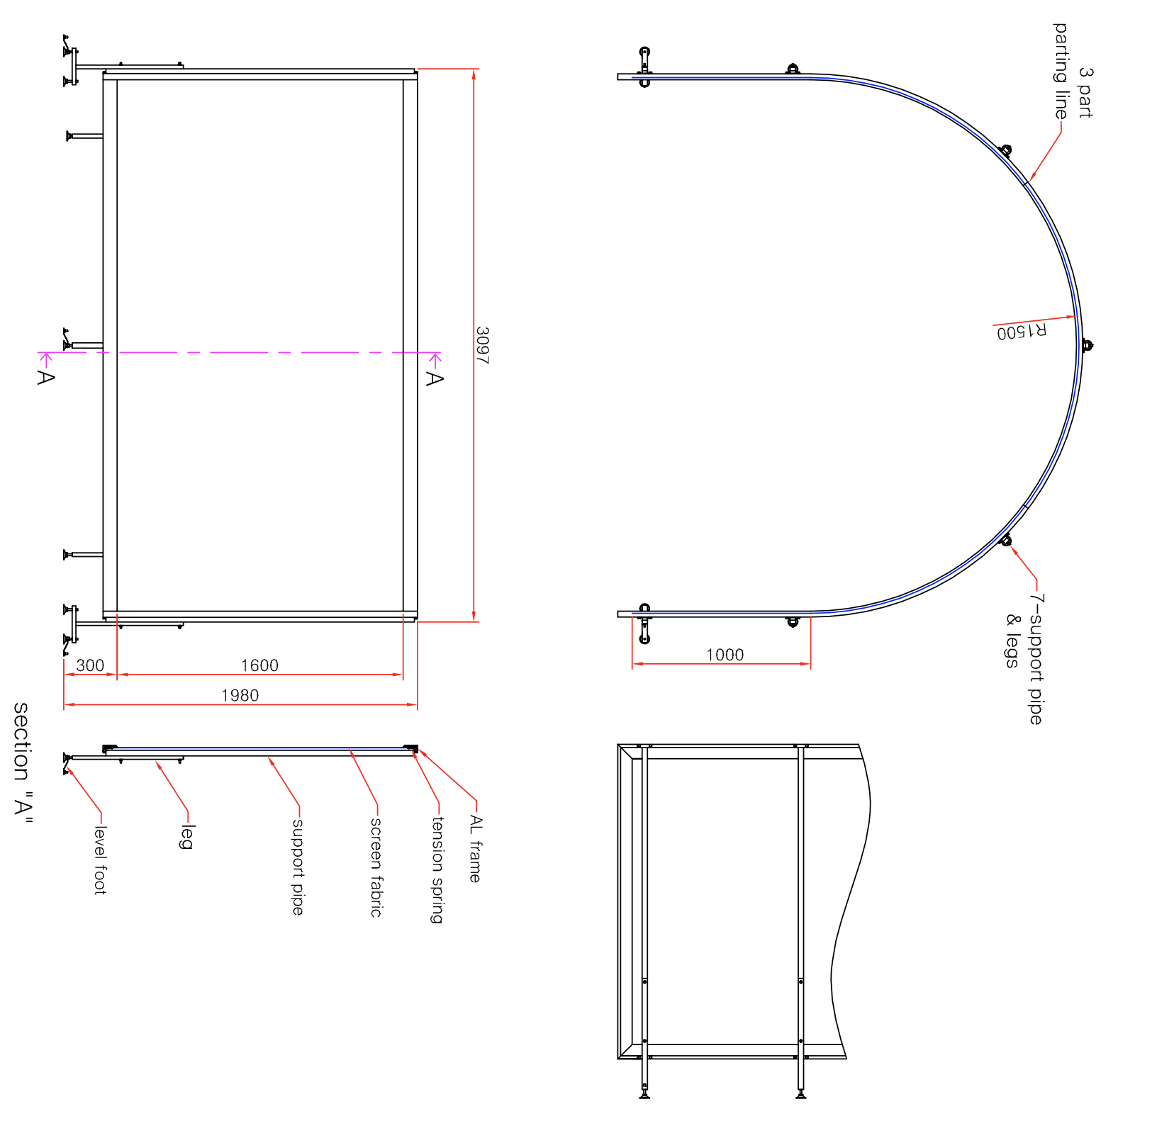

Three BenQ TK700STi 4K short throw projectors are used. The projectors are mounted using BenQ CM00G3 Ceiling Mounts. These mounts have a capable locking feature that holds the projector in place once positioned.

Configuring the PC

Whilst the Nvidia 2080 was able to drive a triple 1080 screen setup, it struggled with MSFS and triple 4K screens. A new rig was purchased at the end of 2022, it is a step up with an Intel S1700 Core i9 13900K 24 Core CPU and an ATI RX7900XTX 24GB for the primary video card, with a Nvidia Quadro T600 4GB as the secondary video card.

As the screen is relatively large 10m HDMI leads are needed to connect to the projectors. This is where some more learnings occurred. The original HDMI leads were unable to reliably drive the 4K projectors at 10m, and even with new leads 10m appears to be the limit before Active Optical leads are needed.

A second learning was the use of Display Port to DVI adapters, again whilst these work fine for 1080, they don’t work at 4K, so given the 7900 Video card has two Display Ports, one HDMI port, and a USB-C port, adapters where needed. Whilst a 4K USB-C to HMDI adapter was easy to find, I found it more of a struggle finding suitable 4K Display Port to HDMI adapters (some of this may have been due to the cabling issues described in the previous paragraph.

A considerable amount of time was wasted trying to get the perfect warp and blend, were a screen that had been correctly warped starting moving about while calibrating other screens. Initially I thought this may have been a side effect of calibrating other screens in Fly Elise, so decided to baseline using dots placed on the screen surface. Even without modifying calibration the image moved several centimetres on the screen. Though the issue may have due to movement in the shed roof, but noted that the images appear to move upward together, which largely ruled out roof movement. Also ran the shed at 22 ºC for several hours and still continued to see movement, so learned to just ‘put up with it’.

Once the video to the projectors was stable then Eyefinity was just to merge three screens together. If I recall correctly there was a restriction on how many HDMI ports could be in an Eyefinity Group, so my group has a mix of Display Port (to HMDI), USB-C (to HDMI) and a native HDMI port. Calibration was then done for DCS.

AMD Software
- Display. There should be three displays listed.
- Scroll down to the bottom and Select Eyefinity, Combine multiple displays to act as one.
- The software will then attempt to group the displays. The displays can be arranged after they have been grouped.

Projector Mappings within the 7900 Configuration tool
Display 1 – Floor Projector – BenQ PJ DVI-D
Display 2 – Centre Projector – Displayport
Display 3 – Left Projector – Right Screen – Displayport
Display 4 – Right Projector – Left Screen HDMI

Monitor Layouts can saved using https://www.nirsoft.net/utils/multi_monitor_tool.html – location for saved files Hornet Documentation → Monitor Configurations Files → Monitor Setup

Enabling Eyefinity is problematic. Lost mouse and 4K resolution when enabling it. The steps for a successful enabling of eyefinity appear require the roof projector to be either disabled or unplugged. Ensure Display Pro is not running and restart after changing the resolution.
As MSFS appears to require separate screens for multiview support the calibration process was repeated with Eyefinity disabled.

Calibrating the Screen

Whilst the Fly Elise software is incredibly capable it is a little complex to operate, and the documentation can be confusing at times. I choose to run with the Ultimate Edition of Immersive Display Pro, this enabled the use of Immersive Calibration Pro which really simplifies the calibration of the curved screen.

One major world of warning is that you need to be incredibly diligent in watching where files are saved as Fly Elise remember the last project export folder, so you can easily find yourself accidentally overwriting earlier work. I found using Github helped reduce the pain associated with accidentally overwriting files as you have a recovery point should you accidentally stomp over a file.

Once the calibration is complete, the files can then be exported for warping. Note that the exported files will typically need to be copied to the C:\WARP folder, they can be located in sub-folders. For DCS the monitor.lua file will need to be modified, for MSFS 2020 the process is currently a little more manual.

Getting started with Calibration Pro

First ensure the screens are correctly ordered in windows, I found having an additional monitor that wasn’t warped was very useful. It was not selected as the primary monitor as DCS expected to start on the primary monitor. This screenshot needs updating to capture the additional monitor. The Eyefinity software does allow you to reorder the screens after quick setup.

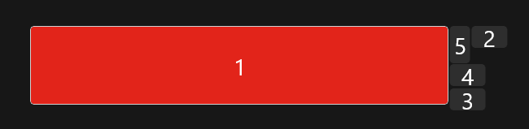

Calibration Pro is free, but its output can only be used with the Ultimate version of Immersive Display Pro. As Calibration Pro is engineered to work with both single and multiple computers it does require the Bonjour networking protocol to be enabled on the computer. Even if a single computer is used, Bonjour must be installed.

- Download and install Calibration Pro. It installed in the Downloads Directory.
- Install Github Desktop and clone the Repo. This should be used to save the configuration settings.
- Disable the Windows Firewall (this may not be necessary)
- Run the INSTALL_FIRST_BONJOUR batch file, without this the Server will not find the client.

The client module must be started first, and projectors mapped. Once this is done the server process can be started.

Start the Calibration Pro Client. Assuming a 1080 monitor is at the 0,0 screen position the grouped projectors should appear as a single box with
AMD Radeon RX7900 XTX
Generic PnP Monitor
Position 1920,0
Resolution 11520x2160
Projectors 3x1

Start the Calibration Pro Server. It should list the three projectors as used. If they are not present check the client can see them and Bonjour has been correctly configured on the PC.

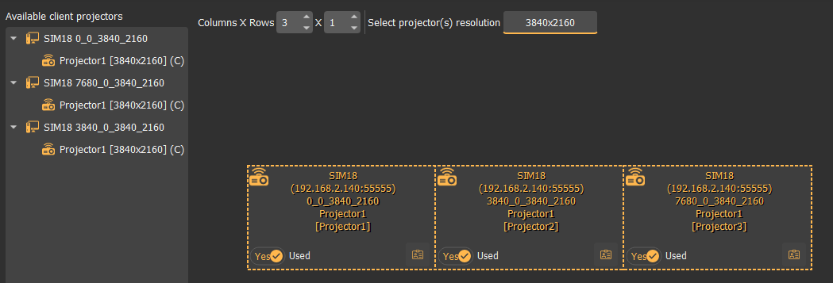

The project file is listed at the bottom of the screen and by default lives in the directory the program is install in – eg Downloads\Immervi..Pro_v5.1.1\Immervi..Pro_v5.1.1\. Change the project directory to the target directory in the Github Repo.

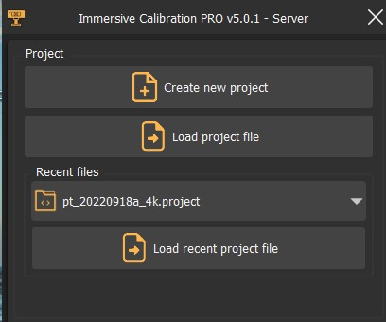

For my project this is .\Hornet Documentation\Fly Elise and then either 4K or 1080.
Once the screens are aligned explicitly set the save folder to the same directory. I’m exporting the following
- Procalib Warp & Blend
  - Single frustum (single.procalib)
  - (Perspective) Multi frustums (multi.procalib)
- Microsoft Flight Simulator
  - MSFS Multi-PC (single Projector per PC) [Experimental]
  - Was unable to select MSFS Single-PC (Multi-view) [Experimental]. Unsure why – currently running Calibration Pro 5.1.1
- DCS
  - DCS World (MonitorSetup.lua)

If creating a new project – after creating the new folder and saving the project, go to export and EXPLICITLY set the export folder – otherwise you run the risk be stomping over the previous projects export.

In step 1 the projectors are selected and mapped.
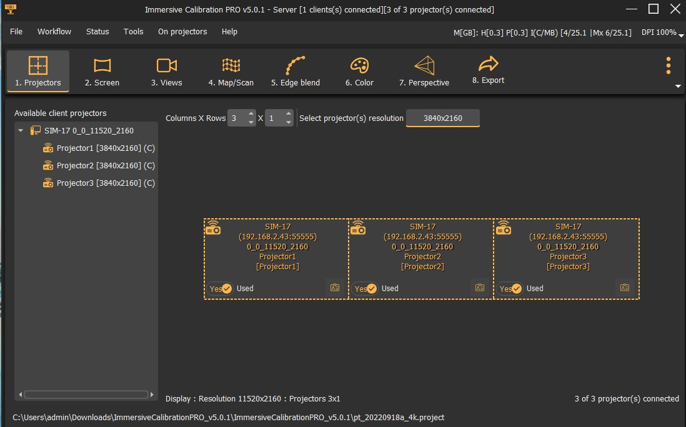

In order for Calibration Pro to create a correct warp, the physical screen dimensions are needed. So in Step 2 we describe the screen.

Screen shape is horseshoe.
Radius 2.000m, begin Vertical -0.8 End Vertical 1.6 Centre 0.8, Leg Length 1.0
It is broken up into 30x10 squares. Calibration Pro calculates the Column width which can used to place the marker dots on the screen frame. I used Avery dots.

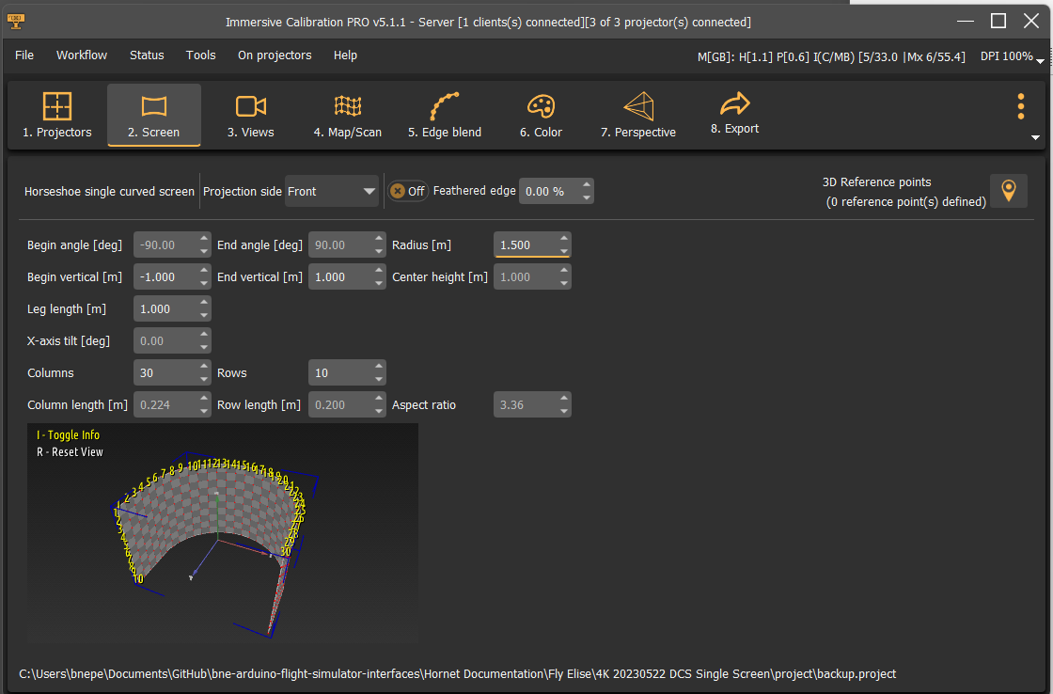

Step 3 involves determining how many columns are assigned to each screen for calibration. As we have three projectors three views are needed.

 | Begin Column | Number of Columns | End Column (derived)
View 1 | 1 | 11 | 11
View 2 | 10 | 12 | 21
View 3 | 20 | 11 | 30

The Mapping view is mapped to screengrid, not a camera.

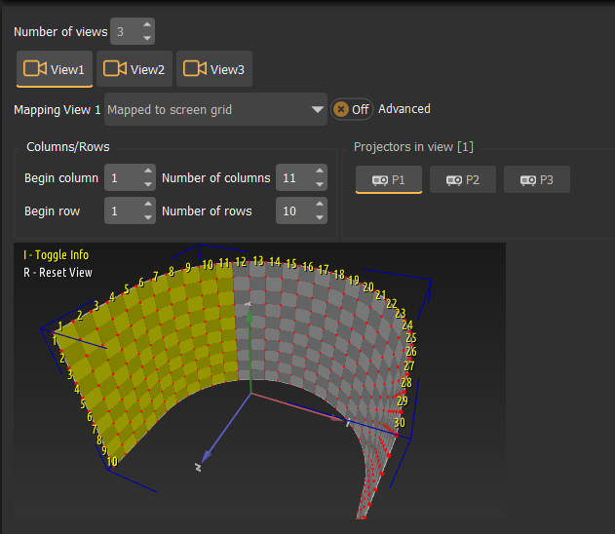
In step 3 we perform the actual alignment of the screen.

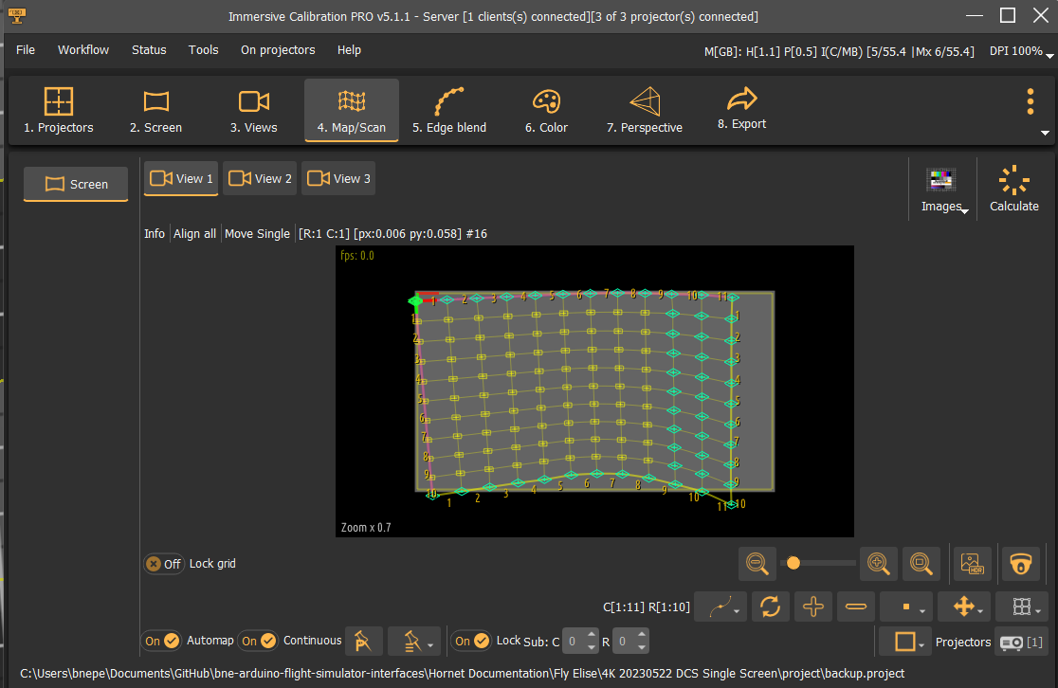
Ensure Automap and Continuous are both on.

An important first step is to lock the corners using space bar to prevent warping weirdness as you map dots. The grid can suddenly become severely distorted without warning so save work frequently.

Use the Shift-Arrow keys for Small movements, and the Ctrl-Arrow Large movements. Use the space bar to lock in a point. Once you are happy with a view the entire grid can be locked to prevent accidental changes. The squares are numbered with both row and column which is invaluable when working on the overlap areas.

I found surprisingly good results where obtained with just locking in the top and bottom rows (after locking in the corners!). There will be points at the edge of each screen that you are unable to see, take a best guess looking at neighbouring lines. Screens can be blacked out using the ‘On Projectors’ menu.

Once the alignment is done press the calculate button. Once you are happy with the square display the image.

In step 4 the amount of overlap is determined. As I had considerable image movement the amount of final overlap is minimised, this unfortunately comes at the cost of fully smoothed brightness.

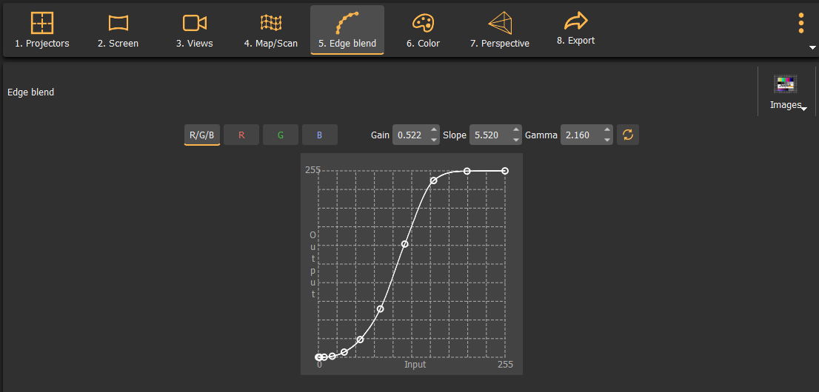
Step 6 was just clicked over as the projectors came form a common batch and colour matched nicely.

In Step 7 the location of the 3d map is done. A new item has been added for MSFS which locked the same FOV for all screens. You may need to click Find Frustums. After selecting Calculate perspective display the tunnel

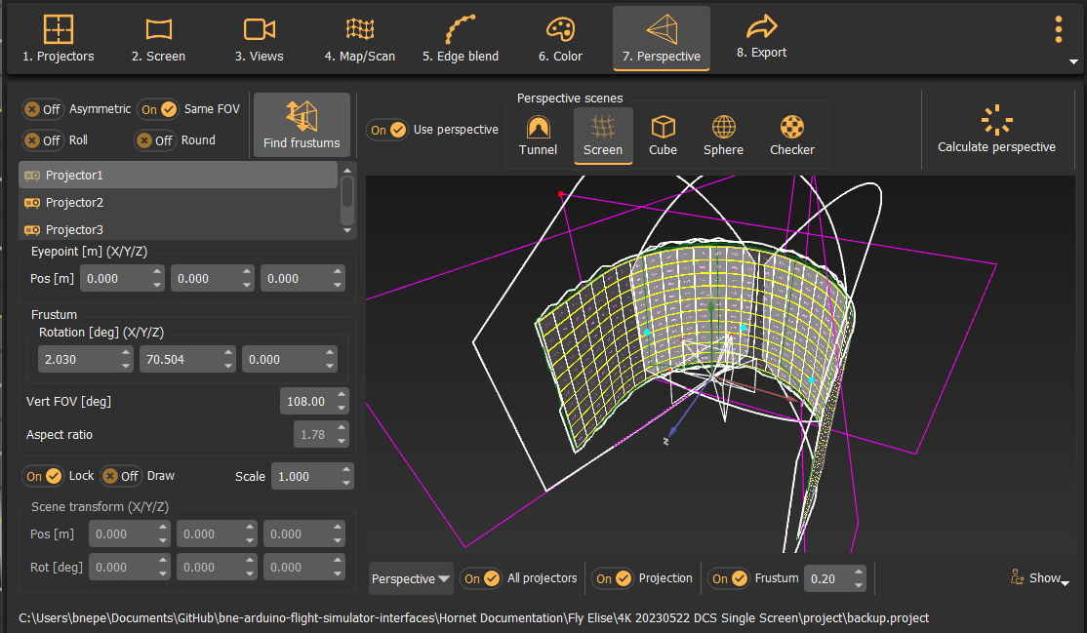

Step 8 exports the Procalib files and the selected simulator files. Double check that the export folder is the one you want.

Export both Procalib, enable DCS (needs two check boxes) and MSFS – check both MSFS options are available, if they aren’t is is likely you’ve not selected lock PoV in step 7.

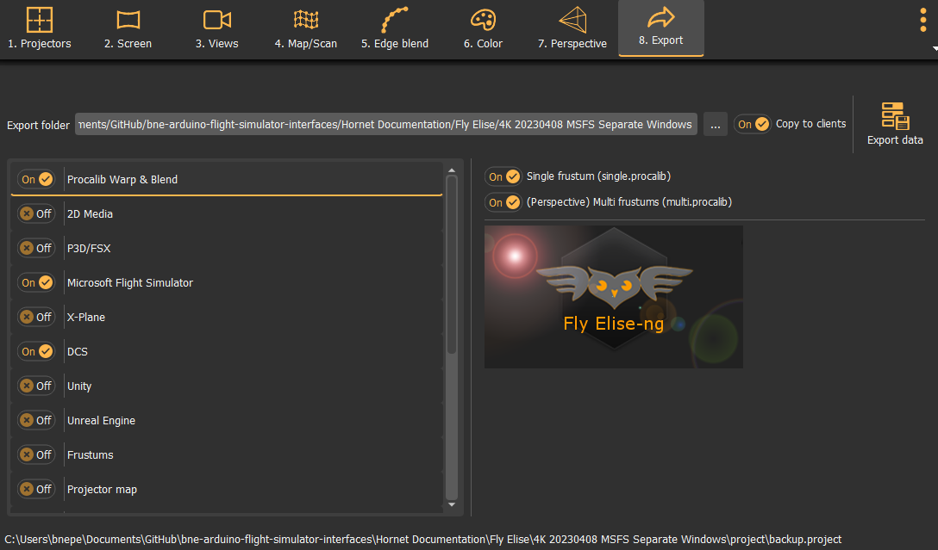
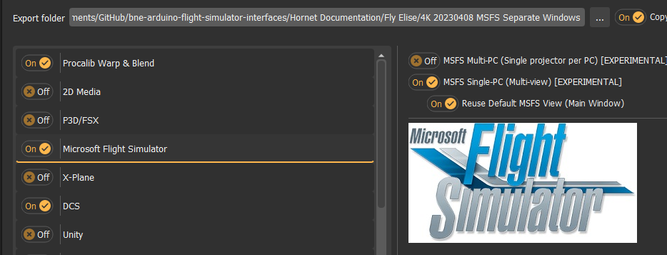

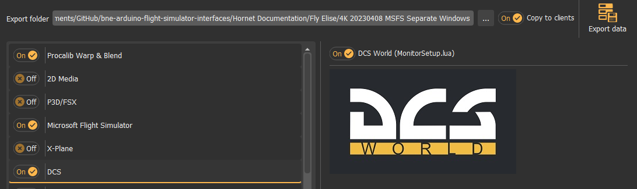
Copy the exported files from the Fly Elise Calibration Pro to c:\wrap000) you are allowed to use folders so make the naming meaningful eg Stretched and Merged. Copy the Monitor.lua file to My Saved Games\DCS]Config\Monitor. The MSFS files contain the recommended setting which can be copy and pasted into sections of configuration files (more on that latter).

DO NOT FORGET TO SAVE YOUR PROJECT BEFORE EXITING!

Immersaview Pro

The first step needed is mapping the projectors – if the screen is stretched the projectors are Groups into a 3x1 layout. A single Procalib file is used for the group for DCS. The Procalib files need to be copied to the C:\WARP folder, use separate folders for Stretched and Multi Screen configurations

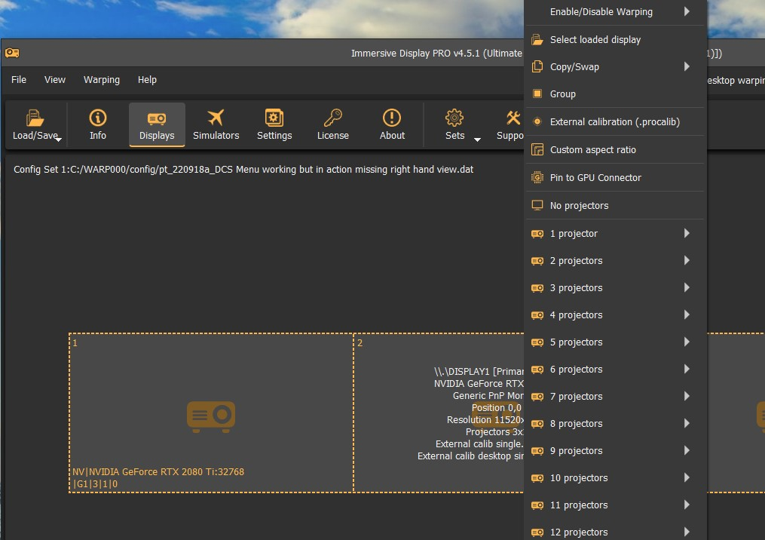
If separate screens are needed (eg for MSFS 2020) then each screen has its own Procalib file, the file name encodes location (eg 0, 3840, 7680)

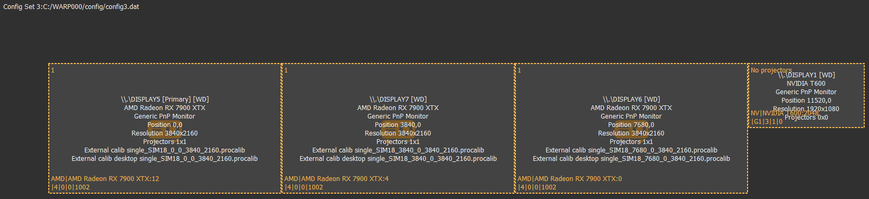
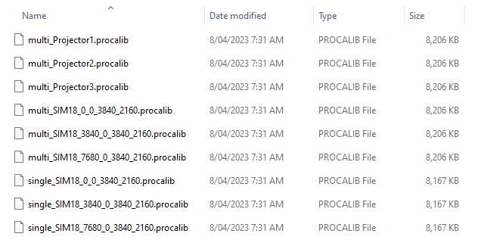

While testing the layouts having keystrokes to enable and disable warping. Desktop and Windows warping are separate functions, and can have interdependencies. Once configuration is complete I’d recommend disabling the keystrokes are the can conflict with other applications as Immersive Pro will grab keystrokes even when it is not in the foreground. Perhaps Toggle Window Warp could be kept. Ultimately the CMDNET interface could be used.

As the default keystrokes clash with DCS settings, using Ctl-Z and Shift-Ctrl-Z. Also disabled all other keystroke options in FlyElise Pro.

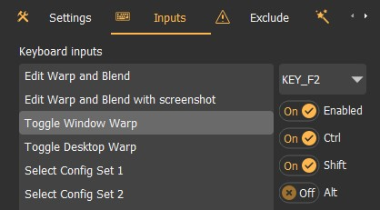
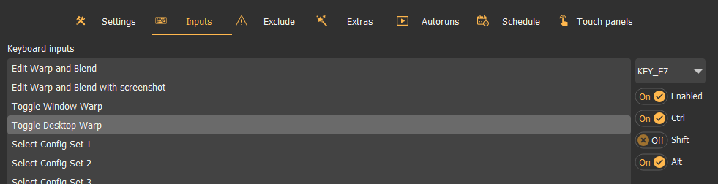
Allow software to render the mouse to enable the use of an enlarged mouse point to make it easier to locate the mouse.

Immersive Display Pro Operations

Firstly it appears you can’t have the best of both worlds (unless I’m missing the obvious) – to get a nice desktop warp and MSFS you need to use single procalib, but to get DCS to warp need multi.procalib. As different projector layouts are needed, separate projects are needed. Within a project you can have different config.sets which I think include using different Procalab files. The Config Sets can be selected using keystrokes – which is good for testing but discouraged for operations. Noting you do need to disable eyefinity to fly MSFS2020

Using Two config sets -
Config Set 1 – Single.procalib – Desktop and MSFS – Shift-Ctl-1 to select – NEED TO VALIDATE THIS ISN”T COLIDING WITH DCS KEYSTROKES
Config Set 2 – Multi.procalib – DCS – Shift-Ctl-2 to select

Configuring a Display Mask

A display mask will stop the project from displaying on items that you don’t want drawn on, for example the canopy bow on the pit.
This is done on a per projector basis in Display Pro. When running Display Pro go into Warp Setup. Select Masking.
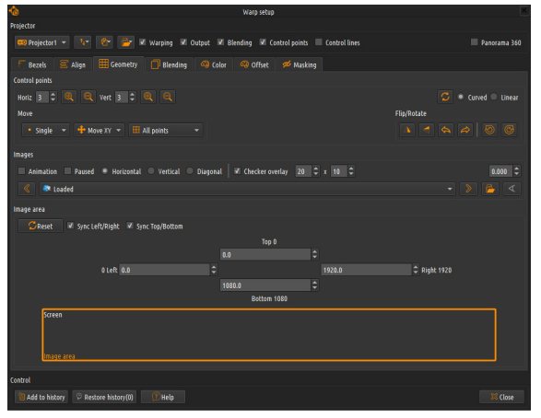
Now draw the shape to block out where the display should be hidden. Note this will actually be displayed in two locations, on the smaller view box in the screen, as well as on the screen itself. I found a couple of times I wasn’t drawing the box large enough so wasn’t seeing it on the screen
After drawing a polygon, press escape, you can then double click on the polygon and drag individual points around.
You can then save the Drawing. This isn’t the mask used, you need to also save it as a bitmap. Once the bitmap is saved you can then select it.
Press ESC to return to the Display Pro Screen and Save the Config file. Three Saves are needed, the drawing, bitmap, and the whole config file.
Enable Warping to validate settings have taken. Have found I needed to exit and restart Display Pro.
It looks like this can also be done in Calibration Pro
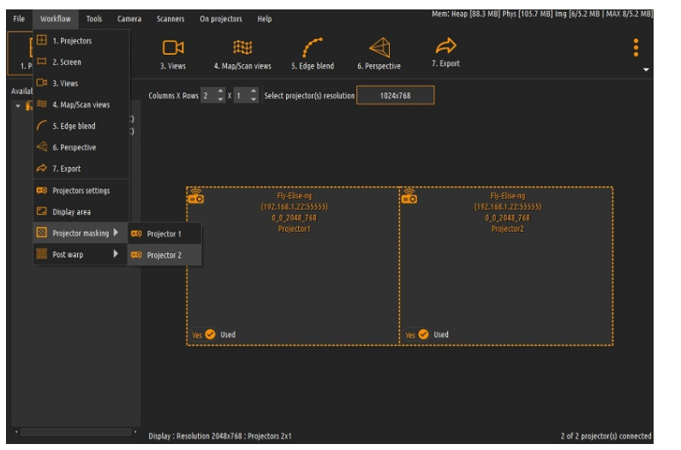

DCS Configuration and Operations

When operating DCS don’t have Desktop warping or Windows warping enabled. Load DCS and start flight, once flight is loaded then enable Desktop warping. If performance has tanked, try toggle warp a few times. If that fails shutdown and restart computer and repeat.
In FlyElise Pro, in the Simulator integration screen select DCS, find the export folder from Calibration Pro (now living in the GitHub repo), and select the root directory for DCS (note two different DCS and DCS Open Beta.

Open DCS and select the Monitor file (Sim18….)

Set and remember the Desktop and Window Warp files. It looks like Fly Elise goes looking for the execution of specific executables to determine if warping is needed or not

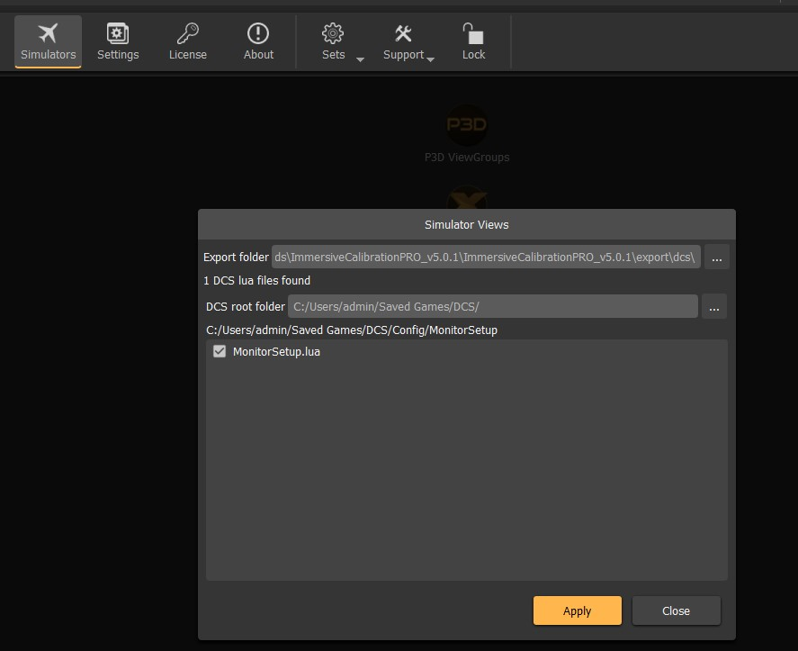

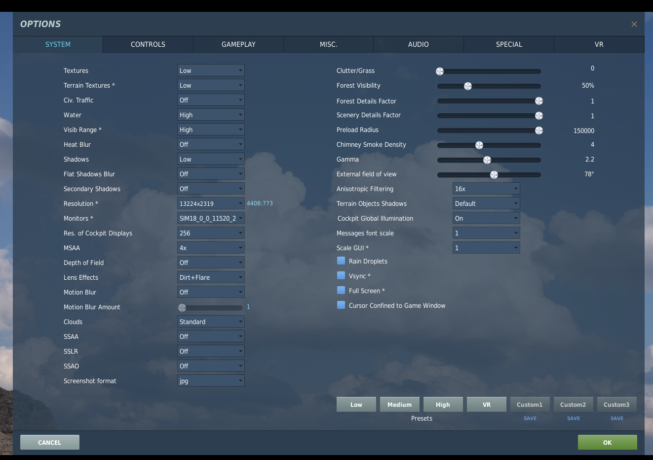

NOTE for DCS you need multi.procalib , but for MSFS you need single.procalib (at least when not using multiview)
WHEN IMPORTING THE SETUP MONITOR FILE YOU WILL NEED TO RE-ADD THE OTHER VIEWS

I found display both the warped and warped cursor was useful
Import the hardware Cabliration file that was copied to c:\warp000
Use the Multi-projector calibration fie
Select Games DCS and Specify the folder in Saved Games – it only goes looking for monitor.lua

In DCS – do not use Full screen, Set the Screen resolution to cover all screens – select the Monitor.lua file.
While doing initial trouble shooting you may want to select one screen

AFTER ENTERING THE AIRCRAFT VIEW NEEDS TO BE CHANGED TO ALIGN THE HORIZON. THIS VIEW CAN BE SAVED AS A DEFAULT VIEW ONCE IT IS ALIGNED.

Setting up separate screens for MSFS

Multiple Views was introduced mid-2022 for MSFS. Whilst currently not as capable as P3d or DCS, the multi-view capability is now functional enough to use.

Whilst the Fly Elise document has correct fragments it is confusing to setup. As with DCS the procalib files are the used for image warping. Additional steps are needed to get MSFS to work correctly.

At a high level the steps are:
- Set the MSFS 2020 Zoom value in Immersive Display Pro
- Configure default eye point for each aircraft
- Enable multi-view configuration (global setting)
- Optionally disable aircraft interior and exterior views

Firstly the multi-view configuration (which is still experimental in April 2022) need to be configured. For the triple projector screen two views must be added. Whilst the Fly Elise documentation warns against using the MSFS GUI, I found it was the only way to get a working solution.

Get MSFS into windowed mode and locate on the left hand projector screen as this is the layout expected by Fly Elise. Camera file edits are not reflected until the Sim is restarted, new aircraft and flights don’t force a reread of the configuration file.

Window 2 is left hand side
Window 1 is right hand side

If the cursor is lost in MSFS the following keystrokes may help
CTL-Enter to fly
END to exit flight
Arrow Key to move between selections, first press up up and the outline of the selection box should appear.

Camera View Adjustments
Options → General Options → Camera
Disabled Camera Shake

Configure Zoom in Immersive View Pro

An important nuance I hadn’t noted early in the warping process is that, due to the complexities of working with curved screens and multiple views, you should not adjust the zoom once configuring is complete. As each view curves as you approach the edge (at least in MSFS) you will only have a single zoom where the horizon is correctly aligned.
The recommended value is find in the output text file from Calibration Pro, what is a little confusing is the MSFS GUI refers to the MSFS Options in Immersive Display Pro, not MSFS itself. If you attempt to change the zoom within MSFS, Fly Elise will set to back to the value in the Fly Elise gui.

As of 2030424 the zoom is set to 60%
------------------
Set the ZoomPercentage in MSFS GUI to 42.0656
Channel = 1
ProjectorName = Projector1
Enter the following values in the cameras.cfg file
InitialZoom = 1.0
InitialPbh = 9.8967, 0, -66.0839

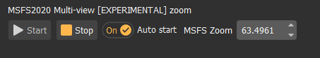

Configure Multi-View

This is a Global Setting and not done per aircraft. It can be copied from the MSFS Text file exported from Calibration Pro, however I found it was not usuable. The configuration is held is the following file.

C:\Users\bnepe\AppData\Local\Packages\Microsoft.FlightSimulator_8wekyb3d8bbwe\LocalCache\UserCfg.opt

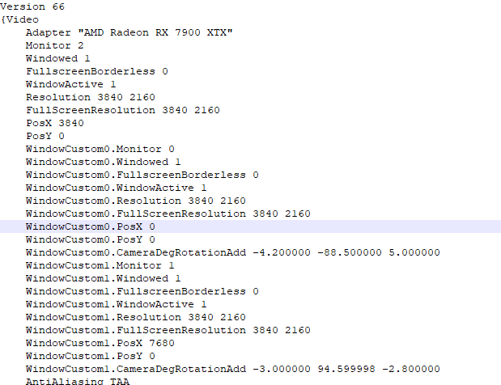
NOTE – WindowCustom2 is not active – used for top down view for helicopter.
WindowActive 1
Resolution 1594 1383
FullScreenResolution 3840 2160
PosX 4435
PosY 316
WindowCustom0.Monitor 1
WindowCustom0.Windowed 1
WindowCustom0.FullscreenBorderless 1
WindowCustom0.WindowActive 1
WindowCustom0.Resolution 3840 2160
WindowCustom0.FullScreenResolution 3840 2160
WindowCustom0.PosX 7831
WindowCustom0.PosY 261
WindowCustom0.CameraDegRotationAdd 3.300000 70.000000 6.200000
WindowCustom1.Monitor 0
WindowCustom1.Windowed 1
WindowCustom1.FullscreenBorderless 1
WindowCustom1.WindowActive 1
WindowCustom1.Resolution 1902 991
WindowCustom1.FullScreenResolution 3840 2160
WindowCustom1.PosX 287
WindowCustom1.PosY 630
WindowCustom1.CameraDegRotationAdd 2.600000 -60.700001 -6.300000
WindowCustom2.Monitor 3
WindowCustom2.Windowed 0
WindowCustom2.FullscreenBorderless 1
WindowCustom2.WindowActive 0
WindowCustom2.Resolution 1920 1009
WindowCustom2.FullScreenResolution 3840 2160
WindowCustom2.PosX 13440
WindowCustom2.PosY 23
WindowCustom2.CameraDegRotationAdd -68.500000 0.000000 0.000000
AntiAliasing TAA
DLSSMode AUTO

I ended up using the GUI in MSFS, it is found in the Experimental Features area. An additional two Cameras are used.

Start a flight, ideally positioning your self in a location where taxi/runway lines extend to the right and left. Press escape in the flight and go to options, experimental options.

When setting these up, start with Window mode so they can be dragged to the correct screen. Once the are correctly located, then change to full screen. If you start with Full Screen selected when adding the view, you may well find you have three views layered on top of one another!

Roughly position the cameras using the GUI, they will be fine tuned later using the scenery mod that provides a number of lines as calibration points.

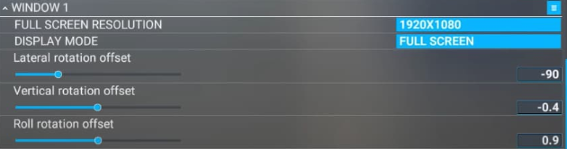

Disable Interior View

This stops MSFS displaying the aircraft interior view and is done for each aircraft. In earlier releases this prevents enabling Nose Wheel Steering for the Hornet, have not validated if this has been addressed in later builds.

File Location:
C:\Users\bnepe\AppData\Local\Packages\Microsoft.FlightSimulator_8wekyb3d8bbwe\LocalCache\Packages\Official\OneStore\microsoft-aircraft-bell407\SimObjects\Airplanes\microsoft-aircraft-bell407\model\model.CFG

Modify Aircraft model.cfg file to remote interior and exterior from view

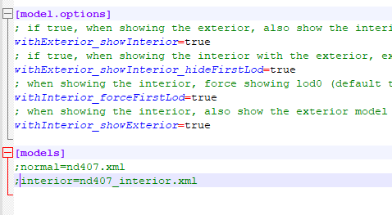

Modify the Aircraft Camera Definition
This is done on a per aircraft basis. Two things should be done, firstly set the Inital Zoom to 1, and then set the pilot desired head view (Initialpbh). This should be done before fine tuning the other cameras. I’m hoping the line can be copied between aircraft as camera definitions are only reread on a restart of the sim.

If this is not set correctly the Horizon will not be flat, as a quick workaround adjust the view up and down with the view hat on the joystick, ultimately best to correctly set the camera in the config file.

NOTE Camera definitions are not read on each flight – instead it appears to you have exit the Sim

C:\Users\bnepe\AppData\Local\Packages\Microsoft.FlightSimulator_8wekyb3d8bbwe\LocalCache\Packages\Official\OneStore\microsoft-aircraft-bell407\SimObjects\Airplanes\microsoft-aircraft-bell407\cameras.cfg

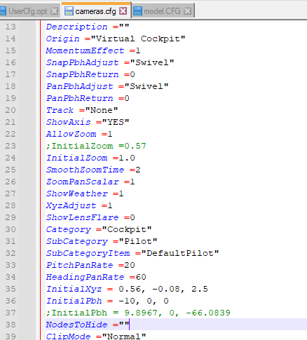
[CAMERADEFINITION.0]
Title ="Pilot"
Guid ="{195EAB58-9E4A-1E2A-A34C-A8D9D948F078}"
Description =""
Origin ="Virtual Cockpit"
AllowZoom =1
InitialZoom =1.0

Category ="Cockpit"
SubCategory ="Pilot"
SubCategoryItem ="DefaultPilot"
PitchPanRate =20
HeadingPanRate =60
InitialXyz = 0.56, -0.08, 2.5
; These values are on reread on each flight either exit the Sim
InitialPbh = 5, 0, 0

MSFS Triple Screen Calibration utility

A simple scenery mod to help with the visual alignment of Triple screens for MSFS in SU10 beta. First ensure you have set the Intialpbh in the aircraft configuration file.
https://flightsim.to/file/36896/triple-screen-calibration-utility

Download =- unzip and then copy to community folder.

Load your plane into icao TRIP and use Parking 3 Dock – GA. If TRIP doesn’t appear then you’ve made a mistake expanding the unzipped mod into the community folder.

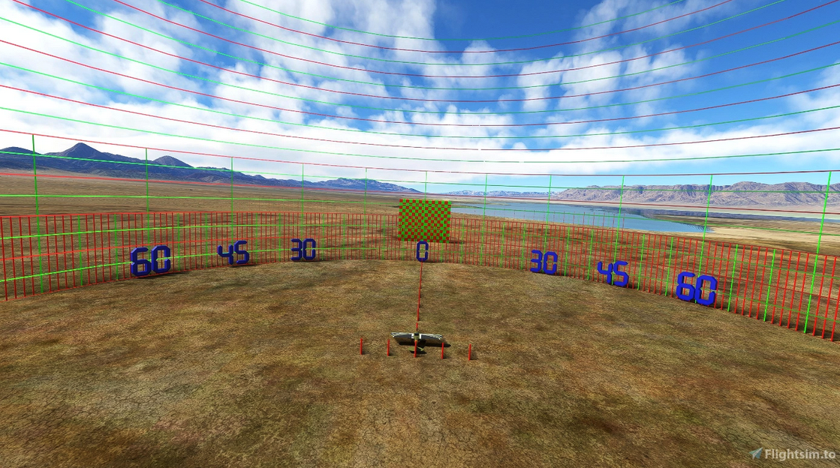

In the physical sim, position yourself where the seat will be located, and adjust the lateral view so 90 degrees is to the immediate left and right. Unfortunately the MSFS GUI hides the forward view so its a bit of trial and error to adjust the roll and vertical sliders.

Probably a good idea to grab the views from the UserCfg.opt file

C:\Users\bnepe\AppData\Local\Packages\Microsoft.FlightSimulator_8wekyb3d8bbwe\LocalCache\UserCfg.opt

Saving Configuration Files

A simple batch file copys the relevant configuration files to C:\XFER, where they then can be copied to the github repo.

copy C:\Users\bnepe\AppData\Local\Packages\Microsoft.FlightSimulator_8wekyb3d8bbwe\LocalCache\Packages\Official\OneStore\microsoft-aircraft-bell407\SimObjects\Airplanes\microsoft-aircraft-bell407\model\model.CFG c:\xfer\407

copy C:\Users\bnepe\AppData\Local\Packages\Microsoft.FlightSimulator_8wekyb3d8bbwe\LocalCache\Packages\Official\OneStore\microsoft-aircraft-bell407\SimObjects\Airplanes\microsoft-aircraft-bell407\cameras.cfg c:\xfer\407

copy C:\Users\bnepe\AppData\Local\Packages\Microsoft.FlightSimulator_8wekyb3d8bbwe\LocalCache\UserCfg.opt c:\xfer
xcopy c:\xfer . /s
pause

CMDNET

CMDNET is a simple TCP interface to Immersive Display Pro – a proof of concept Python code proved that warping can be enabled/disabled along with Config Set selection. This ultimately is a better way to control warping as it can be integrated with Simulator API interfaces to automatically control Immersive Display Pro.

Fault finding

DO NOT RESTART THE COMPUTER when enabling Eyefinity – instead do a full shutdown as a reload appears to trigger a loss of Eyefinity groups. It appears that having the 4th projector (top down view) confuses the computer and results in the computer booting with now displays enabled.
Power off/on and even clearing CMOS configuration did not clear he issue. Tried unplugging all screens, and just connecting an individual screen didn’t help either. After a number of restarts (including pressing F8 on startup) the computer finally rendered a boot image on the desktop monitor.

Check all three projectors are correctly listed in Windows Display Settings. Have had issue where the Projectors ‘fell off’ the PC when incorrectly setting using Nvida instead of ATI warping, ultimately decided to run with Windows Warping. The impact was it disabled the projectors in Windows

If only a single cursor is present and MSFS 2020 is running slowly – shutdown and restart the computer – you will usually identify if there is an issue with the speed of the hanger doors

If you start the Calibration Pro client and no projectors are present – it is possible the Eyefinity grouping has disappeared

Tried reducing the resolution to 1080 per projector, but when Eyefinity groups displays it sets them to 4K, and there doesn’t appear to be a way to reduce resolution once the displays are reduced

If you have rearranged the screens, Display Pro will warn about not having a matching configuring, check the position display in Display Pro to validate they are correctly aligned, eg all sitting in at the same level.

After adding the fourth projector (top down 1080), it squeezes its output into half height. Plug the project into another video card and it displayed correctly. Was unable to swap ports on the primary video card as the display port adapter didn’t do 4K (clearly there is a different in Display Port to HDMI adaptors). The one that wouldn’t drive to 4K had DVI in its description. Issue was corrected by a full shutdown and restart of the computer with the projector connected.

If redoing the Eyefinity group, unplug the roof projector otherwise it automatically creates a group including the roof projector and lowers the resolution of all screens to 1080.

